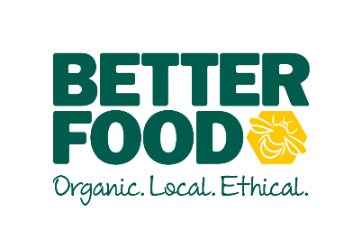  main objective…  To understand how your food production and quality of care put into the food will improve the overall customer experience and business  To prepare and cook food to serve in the Café / Deli, supervising team members to ensure the smooth running of the café /deli and maintaining standards.  Having a can do, infectious positive attitude which resonates throughout your team.  key performance indicators…  - Cook, prepare and facility the production of food from CK for distribution to other sites  - Wastage  - Production Targets  - Team Development  - Health and Safety Compliance | CHEF  To support the Head chef  to lead and inspire the teaM AND IMPROVE SERVICE ACROSS OUR KITCHENS.  accountable for….  KEY DUTIES  - Preparation, production and serving of meals, snacks and drinks, including soups, cakes, frittatas, salads and daily specials.  - Ensure efficient ordering, receipt and management of stock, including monthly stock takes, so that the department is adequately and appropriately stocked whilst adhering to department profit margins.  - Responsible for the quality and range of products sold in the Deli/ Café including those produced in house. Being responsive to the consumer within the parameters of the company ethos (local, organic etc) and purchasing guidelines.  - Ensure all items on the daily specials menu are priced appropriately to achieve target margins.  - Ensuring that the appearance of the café/ deli including the “grab and go” fridge is always abundant, clean and tidy.  - Creating a welcoming atmosphere for the customers to the store by greeting customers and giving excellent customer service. Reporting any customer service issues to the management team.  - To assist customers by developing good knowledge of products, special diets and link-selling opportunities.  - To adhere to standards of appearance, hygiene (both personal and café/ deli), timekeeping, work ethic and customer service.  - To undertake daily routines including cleaning, as trained with purpose and efficiency.  - Maintain security by being vigilant at all times to potential thieving and stock loss.
I (NAME), can confirm I have read and understood what is expected of a Chef at Better Food.

Employee Signature ………………………………………………Date…………………………….

