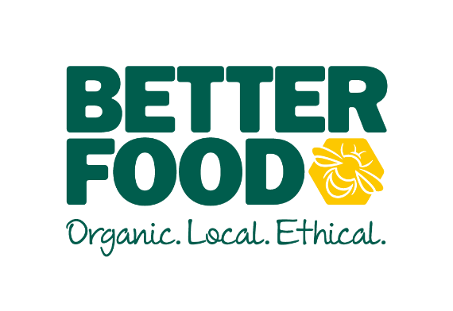
JOB DESCRIPTION: MARKETING MANAGER

Reports to: Managing Director
Direct reports: Brand, Digital & Community Marketing Team
Responsible for: Managing external marketing & design consultants
Role Mission: To help us achieve our purpose, and aspiration by:
- building a growing, loyal and engaged customer base by designing appropriate marketing strategies;
- building knowledge and confidence in all our staff by shaping company policies and marketing strategies;
- developing branding style and messaging consistency in stores, PR communications and in ad hoc projects;
- being a valuable, contributing member to the Central Leadership Team (CLT);
- being a great manager to our company and team (and indirect reports)
Key Responsibilities
- To understand and build an engaged and loyal customer base
- Create and coordinate content to ensure we are a leading voice in our industry (activities such as, but not limited to, website content, interactive social media, press, printed and emailed newsletter, events, networking and public speaking);
- Ownership of the marketing strategy, understanding our customers and establish processes to develop long-term relationships (activities such as, but not limited to, customer surveys, focus groups, social media, responding to customer feedback etc.);
- Keep up to date with and communicate as appropriate, consumer and FMCG articles and research relevant to the organic, ethical, local and independent sector;
- Lead on digital marketing developments – social media and web-based. This may include supporting the development of e-commerce.

- To be Better Food’s advocate in the community
- Be visible and active in Bristol’s food community, and in relevant networks within Bristol and nationally. This will include attending and speaking at public events, networking and seeking opportunities to partner with like-minded organisations, businesses and charities, and align Better Food appropriately as advocates for positive change.
- Lead on our charitable projects with activities such as planning events, fundraising, communications, partnership development;
- Champion all CSR related activities and policies

- To be a valuable, contributing member of CLT
  - Work to the business’s planned objectives through a marketing strategy agreed with CLT;
  - Bring fresh ideas and suggestions to drive business success and help meet targets;
  - Be knowledgeable and participate fully in all relevant business areas

- To undertake the planning, management and implementation of a range of physical branding-related tasks, such as
- existing store refits, re-lays and brand updates;
- new store branding;
- in-store signage, storytelling, POS and merchandising
- supporting buying with own-branded retail and café product development;
- printed material, such as Christmas order form, newsletters and other items as appropriate.

- Be a great manager to our company and your team (and any indirect reports)
- Be a good role model and work to agreed management responsibilities

- Other tasks and responsibilities, as reasonably assigned
Qualifications:
- At least 2 years relevant experience in a retail marketing environment;
- A commitment to our mission and values.
Values & Capabilities:
In addition to aligning to our core values the right person will also possess the following capabilities:
- The ability to keep on track and follow a marketing plan, whilst being flexible enough to take on unplanned projects at short notice.
- Be innovative and creative in a wide range of activities
- Have excellent communication and interpersonal skills
- Be able to lead and delegate

Reviewed October 2019

