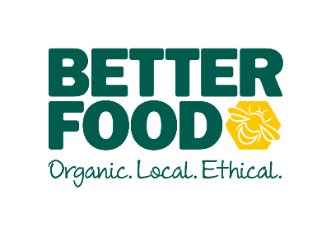  main objective …  To develop and deliver a successful store in line with Company guidance and best practice.  To have a can do, infectious positive attitude which resonates throughout the business. To work collaboratively with other Store Managers and CLT to develop Best Practice.  key performance indicators …  - Gross Margin (£ & %)  - Payroll (£ & % of sales)  - Waste  - Sales across departments and as a whole  - Trained, engaged and knowledgeable teams | Store Manager  To TAKE FULL OWNERSHIP OF A STORE  The job involveS …  Be a great manager to our company and your team.  - Maintain a positive, can do attitude, be a great role model  - Work within the wider Senior Management team to deliver company-wide results  - Provide great communication and expect this from others. Ensure communication is excellent (up, down and sideways) through team meetings, FLASH meetings, one-on-one’s etc.  - Ensure we have healthy, productive teams.  - Manage workloads appropriately  - Ensure that direct reports are inducted, trained and compensated appropriately  - Ensure department managers and supervisors are strong leaders and ensure there is a continuity plan for absences and resignations.  - Lead, support, and develop department managers and supervisors as well as identifying and developing future team leaders.  - Ensure a robust performance management approach with direct reports,  - Perform informal reviews monthly with your direct reports (Check Ins)  - Perform formal end of year reviews.  - Oversee the staff rota including holidays – ensuring adequate cover in the store at all times.  - Recruiting and hiring in line with the Better Food Company ethos.  - Bring fresh ideas and suggestions to drive business success and help meet targets.  - Work in unison with colleagues throughout the company.  - Build a culture of continual improvement within your team.  - Be knowledgeable and in support of:  - Our company purpose, aspirations, customer promise and values.  - Our company structure, resources and goals  - Our customers, industry and competition.  Financial performance  - Own and manage the commercial P&L performance of your store.  - Deliver on KPI’s including but not limited to sales, wastage, margins and wages.  Customer Service  - Deliver on our customer promise in the store at all times.  - Seek out and act upon customer feedback.  - Ensure that impeccable service is set as the standard and that prioritising the customers’ needs is ingrained in the store team’s behaviour.  - Ensure store merchandising is appealing and fresh, full, clean and tidy  Stock Control  - Work through stock controllers to ensure stock levels and accuracy of Vector, as well as timelines of data entry.  - Ordering.  - Work with team to execute pricing, promotions and events – ensuring target margins are met.  - Work with team to mitigate wastage.  Other operations  - Housekeeping and store maintenance including health and safety, fire safety and food hygiene.  - Maintaining Soil Association compliance.  - Other operating tasks including opening, closing, cashing up  - Monitor and use MyHRToolkit to manage staff holidays and absence, teaching your team how to use this as well.

