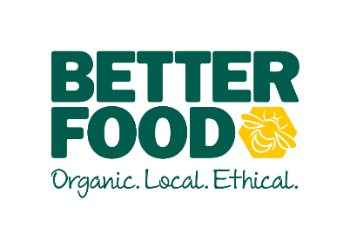  main objective …  To deliver excellent customer service in order maintain and improve the overall customer experience.  To support the Produce Supervisors and Co-Ordinator with the general department-related tasks.  To have a can-do, infectious, positive attitude, that resonates throughout the team. To harness a culture of ownership.  key performance indicators …  - Sales performance across the department.  - Minimising wastage  - Great customer satisfaction  - Look and feel of displays etc. | Fresh Produce Assistant  The job involveS …  Maintaining high standards when handling fresh fruits and vegetables and maximising on-shelf availability for customers by working with pace and efficiency when completing all tasks.  - Gather and maintain a good working knowledge of fresh produce, including seasonal availability  - Advise and serve customers in the Fresh Produce Department whilst observing our duty of care to customers.  - Ensuring high standards of quality control are maintained.  - Refilling fresh produce efficiently to create beautiful and abundant displays, with an eye for detail and keeping to visual merchandising standards.  - Seeing in deliveries of fresh produce, checking stock for quality and matching against delivery notes  - Claiming for spoilt produce by following correct procedure and communicating effectively and professionally with our trusted suppliers.  - Regular cleaning of displays and produce preparation area, in line with Food Standards Agency and Soil Association standards.  - Completing prepacking tasks to the Better Food standard with correct weights and labels.  - Checking produce origins are consistent between invoice, box label and price label, in line with DEFRA rules.  - Communicating with fresh produce teams in other Better Food stores to maintain a common set of standards  - Working on Microsoft Excel to record wastage and shop transfers of produce.  - Working on our in-house EPOS system to search for stock and change prices.  - Being flexible in meeting the customers’ needs i.e. to cover/move departments when necessary  - Processing till point transactions efficiently and maintains till point standards  - Making sure your personal appearance meets the Better Food standards, including the wearing of a clean apron and name badge.

