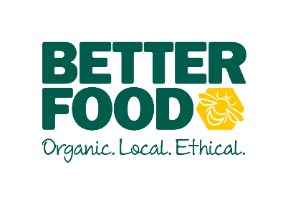  main objective…  To lead, inspire and motivate the instore produce team, leading by example.  To support the Produce Co-Ordinator and Store Manager with the general day to day running of the fresh produce department.  Having a can-do, infectious, positive attitude which resonates throughout the team. To harness a culture of ownership.  To work intuitively to meet the needs of the customer and produce team.  key performance indicators…  - Sales performance across fresh produce  - Providing outstanding customer service.  - Minimising wastage  - Department walks (merchandising, stock levels) | FRESH PRODUCE SUPERVISOR  The job involveS …  Maintaining high standards when handling fresh fruits and vegetables and maximising on-shelf availability for customers by working with pace and efficiency when completing all tasks.  - Gather and maintain a good working knowledge of fresh produce, including seasonal availability  - Advise and serve customers in the fresh produce department whilst observing our duty of care to customers.  - Ensuring high standards of quality control are maintained to avoid unnecessary wastage.  - Ensure efficient ordering, receipt and management of fresh produce, including monthly stock takes.  - Refilling fresh produce efficiently to create beautiful and abundant displays, with an eye for detail and keeping to visual merchandising standards.  - Develop and maintain good working relationships with our key produce suppliers  - Seeing in deliveries of fresh produce, checking stock for quality and matching against delivery notes  - Claiming for spoilt produce by following correct procedure and communicating effectively and professionally with our trusted suppliers.  - Completing prepacking tasks to the Better Food standard with correct weights and labels.  - Checking produce origins are consistent between invoice, box label and price label, in line with DEFRA rules.  - Communicating and offering support to fresh produce teams in other Better Food stores to maintain a common set of standards  - To provide weekly reports to management, assessing and reflecting on sales data, harnessing a growth mindset  - Working on Microsoft Excel to place orders, record wastage and shop transfers of produce  - Working on our in-house EPOS system to manage stock,  - Making sure your personal appearance meets the Better Food standards, including the wearing of a clean apron and name badge.

