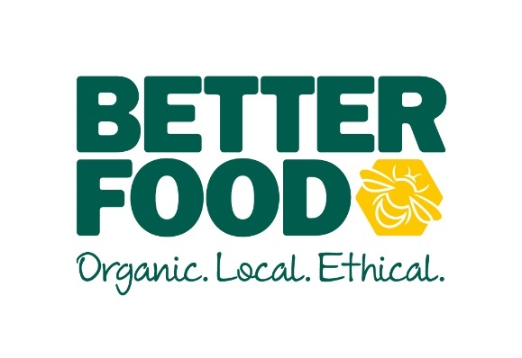
Supplier submission form – Health and Bodycare

Your company and product

- Company name:

- Location:

Why? We prioritise local suppliers.

- Your name:

- Your role:

- Product name/names:

- Where is your product manufactured?

Why? We prioritise locally-produced products.

- Category/categories:

- Number of lines:

- Are you listed with distributors?

- if yes, please state which:

b) if no, what is your minimum carriage paid order value? Please provide a price list.

- What is the ownership structure of your company?

Why? It’s important to us to support brands from a diverse supply chain.

- What is the annual revenue of your company?

Why? It’s important to us to support small brands.

- OPTIONAL: Are any of the majority owners of your business:

- Women

- From a black or Asian background
Please provide further details if you wish (optional):

- Or individuals who identify as being part of other underrepresented or minority ethnic groups or populations
Please provide further details if you wish (optional):

Why? We are taking steps to monitor and, where appropriate, prioritise the stocking of products from businesses that are owned by individuals from underrepresented groups or populations, and to develop our range of products that meet the diverse cultural needs of our community.

Your ingredients: Please answer the ingredients questions in the section relevant to your category: Nutrition & Food Supplements / Body Care or Gifts & Clothing, then move to the final section, which is relevant to all categories.

Nutrition & Food Supplements / Bodycare

- Is your product certified organic? Y / N

- if yes, please indicate the scheme and licence number:
Scheme:
Licence no:
If your product is organic certified, you can skip any question marked with an asterisk* in green

- if no, please answer all questions below.

Why? Better Food is an organic retailer, meaning we will always choose organic certified products over non-organic products. If your product is not organic, we’ll need to check a number of things about its ingredients.

- *Are all of your ingredients traceable to source? Y / N

- Please enter the full list of ingredients below, and fill in the questions across all columns. If you are submitting an application for multiple products, you need not separate by product and you need only list each ingredient once (add rows as necessary):

Ingredient | Country of origin | *Certified organic ingredient? | *If not organic, please provide details of welfare or sourcing standards, including Fair Trade certification where applicable… | Purpose of ingredient in product | Allergen?
 |  | Y / N |  |  | Y / N
 |  | Y / N |  |  | Y / N
 |  | Y / N |  |  | Y / N
 |  | Y / N |  |  | Y / N
 |  | Y / N |  |  | Y / N
 |  | Y / N |  |  | Y / N
 |  | Y / N |  |  | Y / N
 |  | Y / N |  |  | Y / N
 |  | Y / N |  |  | Y / N

- *Can you guarantee that none of your ingredients are genetically modified (GMOs)? Y / N

- *If your product contains meat or fish derived ingredients, can you guarantee that the livestock was not fed on GMO feed? Y / N

- *Does your product contain artificial sweeteners, preservatives, colour or flavours? Y / N

- *Does your product contain hydrogenated fats (trans fats)? Y / N

- Is your product or any of its ingredients tested on animals (including for sale in foreign markets)? Y / N

- Are any of the products in your range:

- Vegan Y / N
  - If yes, is it accredited eg. Vegan Society Y / N

- Is your product certified through a Fair Trade certification scheme? Y / N

If yes, please indicate the scheme:

Why? We prioritise fair supply chains.

- Does your product contain palm oil? Y / N

- If yes:

Is it organic certified palm oil? Y / N

Is it RSPO certified palm oil? Y / N

What level RSPO certification?
- Identity Preserved
- Segregated
- Mass balance
- Book and claim
- Next

Is it certified through another scheme? Please specify:

Why? We are in the process of removing any palm oil that is not either organic or high-level RSPO certified from our supply chain.

- Is your product, or any of its ingredients, air-freighted? Y / N

- Do any of the ingredients in your product come from producers in or near Bristol? Y / N
Please provide details:

Why? We’re keen to stock products that support local food production.

Gifts & Clothing

- Is your product certified organic? Y / N

- if yes, please indicate the scheme and licence number:
Scheme:
Licence no:
If your product is organic certified, you can skip any question marked with an asterisk* in green

- if no, please answer all questions below.

Why? Better Food is an organic retailer, meaning we will always choose organic certified products over non-organic products. If your product is not organic, we’ll need to check a number of things about its ingredients.

- *Are all of your ingredients traceable to source? Y / N

- Is your product or any of its components tested on animals? Y / N

- Please indicate if your product contains any of the following materials, and indicate its sourcing credentials. If you are submitting an application for multiple products, you need not separate by product and you need only list each component once (add rows as necessary):

 | Component material?  Y / N | Please indicate if this material is recycled, recyclable (through Bristol City Council recycling facilities), biodegradable, certified eg. organic, Fair Trade, FSC…
Paper
Wood
Cotton
Other fabric (please state)
Rubber
Bamboo
Plastic
Synthetic inks or dyes
Natural inks or dyes
Other, please state…

- Is your product certified through a Fair Trade certification scheme? Y / N

If yes, please indicate the scheme:

Why? We prioritise fair supply chains.

- Is your product, or any of its component, air-freighted? Y / N

- Do any of the components in your product come from producers in or near Bristol? Y / N
Please provide details:

Why? We’re keen to stock products that support local food production.

Packaging: Every applicant should answer these questions

- Does your product have a refill / reduced or zero packaging option? Y / N
Please provide details:

Why? We’re are continuously looking for ways to reduce packaging at point of purchase.

- Please provide details of your products packaging materials:

Material | From recycled sources? please provide details | Disposal? General waste or provide details of how it can be recycled through Bristol City Council recycling facilities

- Please provide details of your delivery packaging, including any measures to reduce, reuse or recycle:

Why? We are continuously looking for ways to reduce packaging waste in our supply chains.

- Please provide details of any measures taken to reduce, reuse or recycle packaging or food waste in your supply chain:

Why? We prioritise suppliers who can demonstrate commitment to reducing waste in their supply chains.

- Do you offer barcoding? Y / N

- If no, do you intend to? Y / N

Other: Every applicant should answer these questions

- Please provide details of any other current certifications or awards you hold for your product or company:

- Please tell us about any community initiatives you are engaged with as a company:

- Please tell us about any other sustainability targets or initiatives your company is engaged with:

- Please tell us about anything else that makes your company or your products ethical and sustainable:

- Please tell us what makes you different from your competitors:

- Please give details of other retailers you supply within 10 miles of Bristol:

Once completed, please email this form to sourcing@betterfood.co.uk. Please only send samples if you have been asked to by the sourcing team.

Thank you,
The Better Food Sourcing Team

