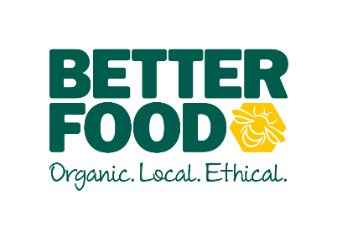  main objective…  To inspire and motivate the kitchen team. – be an excellent team leader and understand how your food production and quality of care put into the food will improve the overall customer experience and business  To support the Catering Manager by coordinating Central Kitchen production and ordering processes.  Having a can do, infectious positive attitude which resonates throughout your team. To harness a culture of ownership across the business.  key performance indicators…  - Cook, prepare and facility the production of food from CK for distribution to other sites  - Wastage  - production Targets  - Team Development  - Health and Safety Compliance | Head chef  To support the CATERING MANAGER  to lead and inspire the teaM AND IMPROVE SERVICE ACROSS OUR KITCHENS.  accountable for….  LEAD BY EXAMPLE  - To be presentable, and ensure the company dress code is being adhered to for all staff.  - Arrive for all shifts on time and organised.  - Treat all teams with respect.  - Demonstrate a controlled and approachable manner  - Cook & Prepare food to the high standard with care for margin, and wastage  STANDARDS  - Maintain high visual standards to create a sense of pride,.  - Ensure efficient ordering, receipt and management of stock, including monthly stock takes.  - To ensure consistent high standards of product delivery across all cafes.  - Ensure costing and margins of all product is correct. Understand and use cater cost for effective pricing and GP%  - Empower and support the chef to prepare, cook and taste food to serve in the café or distributed to other stores.  COMPLIANCE  - To manage the cleanliness and hygiene of the central kitchen  - To ensure pricing and ticketing regulations have been met.  - To manage Health and Safety on a daily/weekly basis.  - Ensure all catering staff and wearing the appropriate clothing to meet EHO/better food standard  - Develop a working relationship with community farm to grow both businesses  YOUR TEAM  - To encourage and motivate your teams..  - Introduce rhythm and routine in the production  - To ensure New Starters are nurtured.  - Support your team through training programs, development plans and any area needed for upskilling.  SUPPORTING YOUR MANAGER  - To be flexible over 7 days trading. To support the needs of the growing business.  - Support the innovation of ‘Grab-and-go’ deli options.  - To improve efficiency across the kitchens.  - To create a ‘One Best Way’ working document.
I (NAME), can confirm I have read and understood what is expected of a Team Leader at Better Food.

Employee Signature ………………………………………………Date…………………………….

