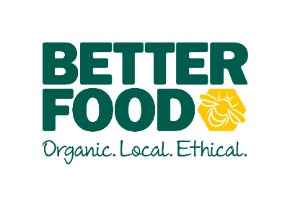  main objective…  To inspire and motivate the kitchen team. – be an excellent leader and understand how your food production and quality of care put into the food will improve the overall customer experience and business  To support the Catering Manager by managing Central Kitchen production, designing menus, and ordering processes.  Having a can do, infectious positive attitude which resonates throughout your team. To harness a culture of ownership across the business.  key performance indicators…  - Cook, prepare and facility the production of food from CK for distribution to other sites  - Wastage  - production Targets  - Team Development  - Health and Safety Compliance | Production Kitchen Manager  To support the CATERING MANAGER  to lead and inspire the teaM AND IMPROVE SERVICE ACROSS OUR KITCHENS.  accountable for….  LEAD BY EXAMPLE  - Ensure the chef dress code is being adhered to for all team members.  - Manage all teams by example.  - Demonstrate a controlled and approachable manner  - Design, cook & prepare food to the high standard with care for margin, and wastage  STANDARDS  - Maintain high visual standards to create a sense of pride,.  - Ensure efficient ordering, receipt and management of stock, including monthly stock takes.  - To ensure consistent high standards of product delivery across all cafes.  - Ensure costing and margins of all product is correct. Understand and use cater cost for effective pricing and GP%  - Empower and support the chefs to prepare, cook and taste food to serve in the café or distributed to other stores.  COMPLIANCE  - To manage the cleanliness and hygiene of the central kitchen  - To ensure pricing and ticketing regulations have been met.  - To manage Health and Safety on a daily/weekly basis.  - Ensure all catering staff are wearing the appropriate clothing to meet EHO/better food standard  YOUR TEAM  - To encourage and motivate your teams.  - Introduce rhythm and routine in the production  - To ensure New Starters are nurtured.  - Support your team through training programs, development plans and any area needed for upskilling.  SUPPORTING THE CATERING MANAGER  - To be flexible over 7 days trading. To support the needs of the growing business.  - Support the innovation of ‘Grab-and-go’ deli options.  - To improve efficiency across the kitchens.
I (NAME), can confirm I have read and understood what is expected of a Production Kitchen Manager at Better Food.

Employee Signature ………………………………………………Date…………………………….

