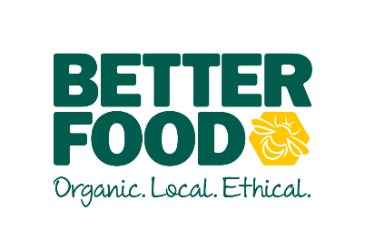  main objective…  To lead, inspire and motivate the Cafe Team, leading by example & offering guidance to your team – showcasing excellent customer service and impeccable attention waste, ordering & compliance to improve the overall customer experience & profitability of the café.  To support the Store Manager with the general day to day running of the store and Cafe.  Having a can do, infectious positive attitude which resonates throughout your team. To harness a culture of ownership.  key performance indicators…  - Sales performance across café and deli.  - Waste percentages across the café and deli  - Look and feel of the café counters.  - Accurate stocktaking  - Managing stock levels  - Payroll & rota’s in line with sales & budgets | CAFÉ MANAGER  To OVERSEE ALL ASPECTS OF managing THE café.  to lead and inspire the team.  accountable for….  LEADING YOUR TEAM  - To encourage, motivate & nurture your café team.  - To ensure good methods of communications  - To be presentable, adhering to café dress code, enforcing the same for the team  - Support learning & enforce standards across the team  - Carry out check-ins, return to works, ROC’s & oversee relevant training (Coffee & Level 2 Hygiene)  - Arrive for all shifts on time and organised.  - Treat the team with respect.  - Create a warm and inviting atmosphere for customers, inspire team to do the same.  - Assist manager with maintaining a strong rota schedule and holiday planning/booking  - Have a positive ‘we can do this’ attitude.  - Delegate and share tasks with your team.  STANDARDS  - Maintain high visual standards of counters & cafe to create a sense of pride, ensuing team do the same in your absence.  - Ensure all daily/weekly checklists are be completed & filed  - Ensure efficient ordering, receipt and management of stock, including accurate monthly stock takes.  - To oversee the cleanliness and hygiene of the café, fridges & café spaces.  - Take ownership & understanding of the profitability of your department  - To comply with all allergen laws & ensure all products are labeled & priced correctly  - Harness of culture of pride in our offering – ensure quality control of all products.  - Keeping all compliance up to date  - Maintaining Soil Association standards,  SUPPORTING THE MANAGER  - To be flexible over 7 days trading. To support the needs of the growing business.  - To be able to open and close the shop & tills securely.  - Maintaining accident reports for team or customer incidents.  - To assist with recruitment of café team  - Confident to take leadership & make decisions in the managers absence

