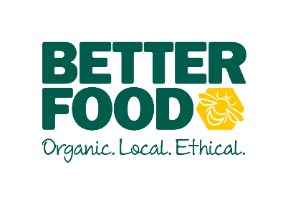  main objective …  Offering outstanding customer service to every customer in order maintain and improve the overall experience.  Operating the tills & serving customers efficiently & correctly  To assist the supervisors in keeping the shop looking immaculate – rotating stock, putting out deliveries, creating displays & labeling items.  To have a can do, infectious positive attitude which resonates throughout the team.  Key performance indicators …  --Excellent customer service  -Greeting all customers  -Helping to maintain and reduce waste  -Rotating stock  -Keeping the shop full fresh & tidy | Customer Service Advisor  The job involveS …  - Engaging with all our customers to create a welcoming, friendly environment  - Maximising on-shelf availability for customers by identifying gaps and replenishing accordingly.  - Replenishing products including top-up of ambient, chilled and frozen  - Maintains the integrity of store stock system, including the correct recording of date expired food  - Maintaining high standards of cleanliness & hygiene  - Helping our customers by giving helpful, friendly and knowledgeable suggestions and advice.  We expect all CSA’s to…:  - Acknowledge & greet each customer, making them feel welcome, taking the initiative to talk and interact with them, sharing information about product offering  - Delivering great service for our customers  - Being flexible in meeting the customers’ needs i.e. to cover/move departments when necessary  - Knowing how to act on customer feedback and who to escalate it to  - Working with pace and efficiency at the till point, make eye contact and smile at customers including those in the queue  - Processing till point transactions efficiently and maintain till point standards  - Correctly rotating stock to ensure the oldest product sells first  - Maintaining a general awareness of the competition, store product range and store navigations  - Understand how customers’ feedback influences delivering great service  - Making sure your personal appearance meets the Better Food standards, including the wearing of a clean apron and name badge.  - Contributing to the sales performance by promoting deals and offers and taking the opportunity to cross sell with each customer interaction  - Confidently talk to & promote our loyalty scheme Bee Better  - Support & offer guidance to new colleagues as they learn their role

