JOB APPLICATION FORM | 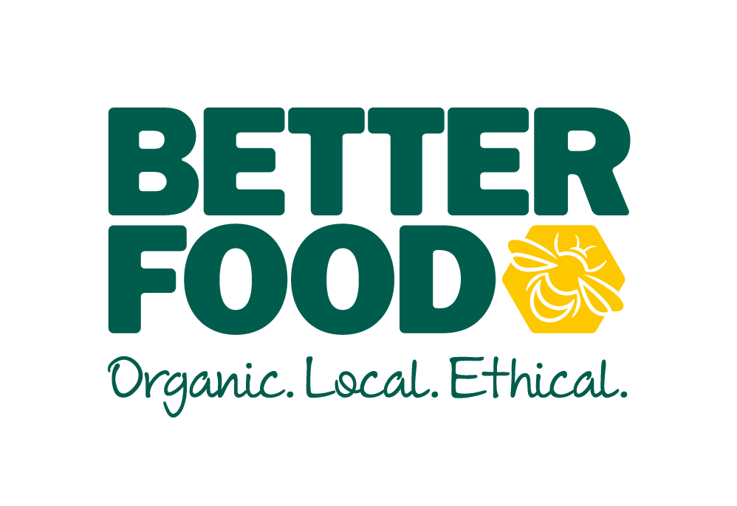

All forms must be emailed to: recruitment@betterfood.co.uk
If you are unable to do this, please contact the People Manager on 0117 935 1725 to discuss alternatives

Post applied for:

Full Name
Address
Post Code
Contact Telephone
Email Address

Do you have the right to work in the UK? Yes / No *
*You must bring your evidence of Right to Work in the UK with you if you are invited to interview – if you are not successful at interview your data will be stored & destroyed in accordance with GDPR rules*

Notice Period: ____________________________________________

Any Holidays Booked (Next 6 months): _________________________________________________

**Please note you will be required to work bank holidays and over the Christmas period**

Availability | Available (Time from – to) or all day | Unavailable (Time from – to) or all day
MON
TUE
WED
THURS
FRI
SAT
SUN

Why do you wish to work for Better Food in this particular post?
What relevant skills and experience do you have that make you suitable for this post?
Please detail clearly how you display the skills / qualities required in the job advert or job description when completing this section. Please include any previous relevant jobs and time spent in the roles.

Declaration: I declare that all the information provided within the application is true. I understand that any false statement may disqualify me from taking up employment or render me liable to dismissal.

Data Protection Act 1998: I hereby grant Better Food and all of its associated companies right to process any personal data contained in this application for all necessary purposes relating to my application and if appropriate, my future employment with them.

Signed: _______________________________ Date submitted: _____________________________

Please note: we will ask you to sign the form, if you are offered the role. The submission date will be the date and time we receive your application.

