JOB APPLICATION FORM | 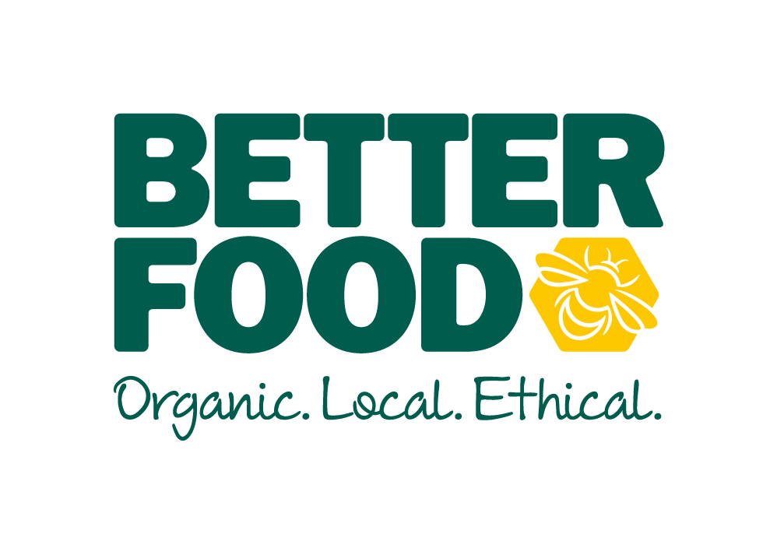
All forms must be submitted to: recruitment@betterfood.co.uk
If you are unable to do this, please contact the HR Manager on 0117 935 1725 to discuss alternatives

Post Applied For
Full Name
Home Address
Post Code
Contact Telephone
Email Address

Do you have the right to work in the UK? Yes No
*Please bring your evidence of Right to Work in the UK with you if you are invited to interview*

Notice Period: ____________________________________________

Any Holidays Booked (Next 6 months): ________________________________________________

**Please note you will be required to work bank holidays and over the Christmas period**

Availability | Available (Time from – to) or all day | Unavailable (Time from – to) or all day
MON
TUE
WED
THURS
FRI
SAT
SUN

Education including further education and relevant training:
Current occupation – Please include date commenced, duties, salary and reason for leaving.
Previous employment in the last 5 years– please detail duties, salary and reason for leaving.
Why do you wish to work for Better Food in this particular post?
What relevant skills and experience do you have that make you suitable for this post? Please detail clearly how you display the skills / qualities required in the job advert or job description when completing this section. (continue on separate sheet if necessary)
References – Please supply 2 references (NB: these cannot be from friends or family members)

Where did you see this job advertised?

NB: If you require any reasonable adjustments during the recruitment process, please contact the HR Manager who will be able to assist you.

Declaration: I declare that all the information provided within the application is true. I understand that any false statement may disqualify me from taking up employment or render me liable to dismissal.

Once you have submitted this application to us, we will process your personal data in line with the Data Protection Act 2018 and GDPR. Please contact us for a copy of our Data Protection Policy.

Signed: Date submitted:

Please note: we will ask you to sign the form, if you are offered the role. The submission date will be the date and time we receive your application.

