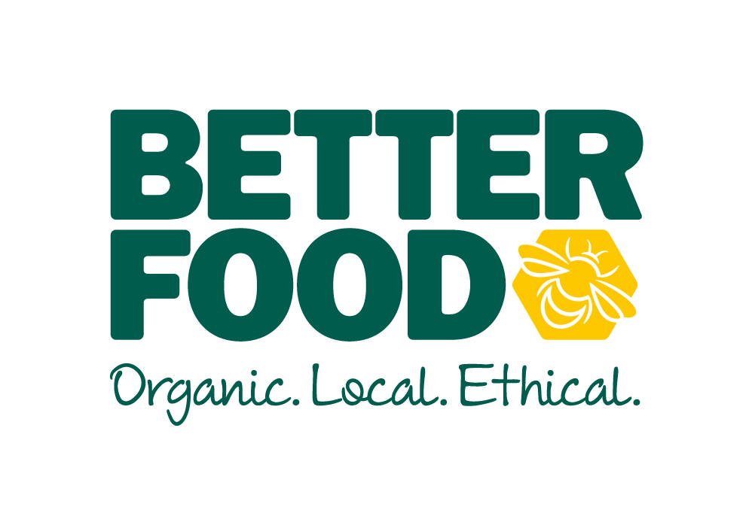

JOB DESCRIPTION: VAN DRIVER

Company Mission: To help us be the best independent retailer and deliver on the company purpose, aspiration, customer promise and values, primarily by delivering excellent customer service throughout all areas of your role.

Working hours: | Shifts – to support 7 day trading
Reports to: | Assistant Store Manager
Direct reports: | None
Role objectives: | To share knowledge and experience with other team members, and to take ownership for own personal development – Transportation of stock, internal post and money.
You job purpose is to give great service and sell to our customers, directly and by doing the jobs required.

Your job profile will give you a clear understanding of what you need to deliver under the Compass: sales, service, standards, people and costs as well as the behaviours you need to demonstrate. It details how your role supports Better Food to become a better, ethical, organic retailer within Bristol and beyond.

Key Responsibilities:

SERVICE
Role specific responsibilities:
To provide efficient transport service between all Better Food sites, ensuring the relevant documentation accompanies all goods.
- Planning the route to make sure that deliveries are made on time
- To ensure you have the relevant driving license for the vehicle used, and to advise Better Food if you receive any endorsements for driving, or arrested for a driving related offence, or receive a notice of prosecution
- To ensure the vehicle used is safe, adequately maintained, clean and tidy each time it is used.
- To comply with policy for the maintenance of the vehicle, and record keeping
- To provide relevant documents associated with the use of the vehicles
- To maintain the highest standards of conduct whilst on Better Food business

STANDARDS

Maintains shop floor standards throughout the trading day for customers and colleagues.
- Ensures products are displayed according to standards, ready for opening and maintained at all times
- Implements principle of ‘clean as you go’ throughout the store

Maintains a safe and legal working environment for customers and colleagues
- Maintains data protection of customer details at all times
- Uses equipment in line with health and safety principles and training
- Follow the highway code at all times and drive in line with UK law.
- Takes responsibility for maintaining equipment
- Has an awareness of potential hazards and takes appropriate action
- Completes all health and safety documentation required, including slip/trip sheet

PEOPLE
Shares knowledge and experience with other team members and takes ownership for own personal development
- Keeps in touch with relevant information and about store and section and shares their knowledge and experience with other team members
- Collates evidence throughout the year and prepares for review conversation, sharing their evidence with the line manager
- Ensures correct working hours and logged
- Pins in and out when starting and finishing shift

COSTS

Minimises losses and works in an efficient and productive manner
- Minimises stock losses through assisting with comprehensive stock control processes
- Works with standard operating procedures to deliver an efficient operation

Values and Capabilities: Connect with our customers and each other by being positive, determined, respectful and taking ownership and responsibility to actively sell.

Expectations: We expect all staff to have a “can do” attitude, to lead and inspire by example and to put the best interests of the company at the forefront of all they do at Better Food.
This includes taking responsibility for achieving and maintaining the highest standards of health and safety in the workplace.

